Israeli Culture Unplugged
Specialty Track 1

AUTHOR(S): | Tomer Moked
SUMMARY: | The Hummus Show: a cool and tasty way to bring intense topics to the discussion table  - Submitted by Tomer Moked
TOPIC(S): | Israeli Culture, Israeli Food, Israel’s Conflicts
LEARNING OBJECTIVE: | 1.Participants will learn how to make hummus and about the connection between food and culture.  2. Participants will face and discuss Israeli social and political topics.
AUDIENCE: | Ages 11-17; Staff Program
TIMING: | 90 minutes
APPENDICES: | Handout 1 -YouTube “All about the Hummus” - https://www.youtube.com/watch?v=ZXPJUyFGMgE  Handout 2 - Humus Challenge Roles (2 copies)  Handout 3 - Recipes (30 copies)  Handout 4 - Hummus Dilemma Menu (6 Copies)
MATERIALS NEEDED: | Projector + Speakers  6 long tables  4 (15-ounce) cans chickpeas  2-4 large lemons  2 cups tahini  4 small garlic clove  2 cup extra-virgin olive oil, plus more for serving  1 teaspoon ground cumin, half cup salt, dash ground paprika, for serving  4 cups water  2 kettles, 1 can opener, 8 bowls, 10 spoons, garlic mincer  Plastic cups  30 paper plates, 3 cutting boards  20 plastic wraps and cloth  Soap and cleaning supplies.  Kitchen gloves box  Darbuka, Tambourine  2 large pita bread snacks
SET-UP DETAILS: | Kitchen or in a room with a sink would be great.  Tables set up: Each 3 attached to create 2 working areas. Set up the materials as needed in handout 2.  With minor adjustments you can run this program anywhere.

Session Timeline & Outline:

The Hummus Show

Trigger (5 min) - Watch “All about the Hummus” - https://www.youtube.com/watch?v=ZXPJUyFGMgE
Facilitator will open by saying that hummus was always a dish that brought people together and we are going to experience the ways it affected our Israeli community.

Opening Activity (20 min) - The Hummus Challenge
Each participant will receive a note with an action and instructions. On their turn and according to the instruction, the participant will take his/her part in the making of the Best Cornerstone Hummus in the world!

The Recipe for the Facilitator use only:
2 (15-ounce) cans chickpeas
1/2 cup (120 ml) fresh lemon juice (1-2 large lemons)
1/2 cup (120 ml) well-stirred tahini
2 small garlic cloves
4 tablespoons (30 ml) extra-virgin olive oil, plus more for serving
1/2 teaspoon ground cumin
Salt to taste
4-to-6 tablespoons water
Dash ground paprika, for serving

- In the bowl of a food processor, combine the tahini and lemon juice and process for 1 minute. Scrape the sides and bottom of the bowl then process for 30 seconds more. This extra time helps “whip” or “cream” the tahini, making the hummus smooth and creamy.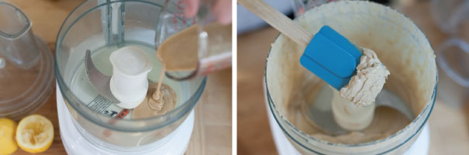
- Add the olive oil, minced garlic, cumin, and a 1/2 teaspoon of salt to the whipped tahini and lemon juice. Process for 30 seconds, scrape the sides and bottom of the bowl then process another 30 seconds or until well blended.
Open, drain, and rinse the chickpeas. Add half of the chickpeas to the food processor and process for 1 minute. Scrape sides and bottom of the bowl, then add remaining chickpeas and process until thick and quite smooth; 1 to 2 minutes.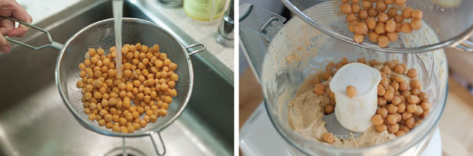
- Most likely the hummus will be too thick or still have tiny bits of chickpea. To fix this, with the food processor turned on, slowly add 2 to 3 tablespoons of water until you reach the perfect consistency.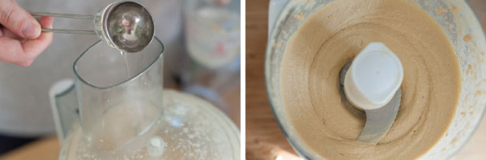
- Taste for salt and adjust as needed. Serve hummus with a drizzle of olive oil and dash of paprika. Store homemade hummus in an airtight container and refrigerate up to one week.

The instructions given to the Participants (Handout 2):

No. | What they need to do | PROPS
1. | Boil Water | Kettle  Water
2. | Open Chickpeas can | Large Chickpeas can  Can opener
3. | Drain and rinse the chickpeas and place them in a bowl. | Bowl
4. | Pour the boiling water into the chickpeas bowl
5. | Add a spoon of salt to the bowl with the chickpeas and hot water, stir, let it sit for 3 min. | 1 spoon  salt
6. | Drain hot water from chickpeas bowl, start mashing the chickpeas until your reach the perfect consistency.
7. | Combine with tahini once it's ready. Mix until you reach your favorite hummus consistency.
a. | Pour 1 cup of Tahini into a bowl. | Bowl  1 cup of Tahini
b. | Add 1 cup of cold water into the Tahini bowl. | 1 cup of water
c. | Squeeze juice of 1 lemon, Add juice from 1 lemon into Tahini bowl | 1 lemon
d. | Mice 2 garlic cloves and add to tahini bowl
e. | Add Salt, cumin and olive oil to tahini bowl
f. | Add a pinch of salt to the tahini bowl and tell the one who stir it: “one last stir, please, we are almost done”.
g. | Stir Bowl of tahini Constantly until salt is added and you are told otherwise.
x. | Play Darbuka | Mini Darbuka
y. | Dance by the Darbuka player
z. | Play the Tambourine | Tambourine

Once Hummus is ready, serve on 6 different plates, add olive oil and paprika, and pita bread snack.
One Hummus serving per table.

Main activity: Hummus Dilemma (45 min)

Participants will split around the tables 2-4 per table

Facilitator will explain: while you and your company enjoy your hummus dip, you are asked to discuss related dilemmas handed to you.
- Facilitator will hand each team a dilemma menu. (Handout 4)
- Allow the participants to choose a topic and discuss it.
- Kindly suggest that they will continue to a new topic every 15 min.
- Facilitator should walk around, sit with the teams, join the discussions, ask challenging questions, and stir the topic by presenting the other side of the coin.

Additional Notes for Bringing it Back to Camp:

You can use past Israeli Culture Cornerstone programs such as the Pita Bread submitted by Tomer Moked to combine with this one.

You can skip the hummus making and just serve hummus dip if you only care about the discussion.
Cooked black Israeli coffee will be a nice addition to a Staff Program.

