iCenter: Approaching Conflicts Toolkit: http://toolkit.theicenter.org/

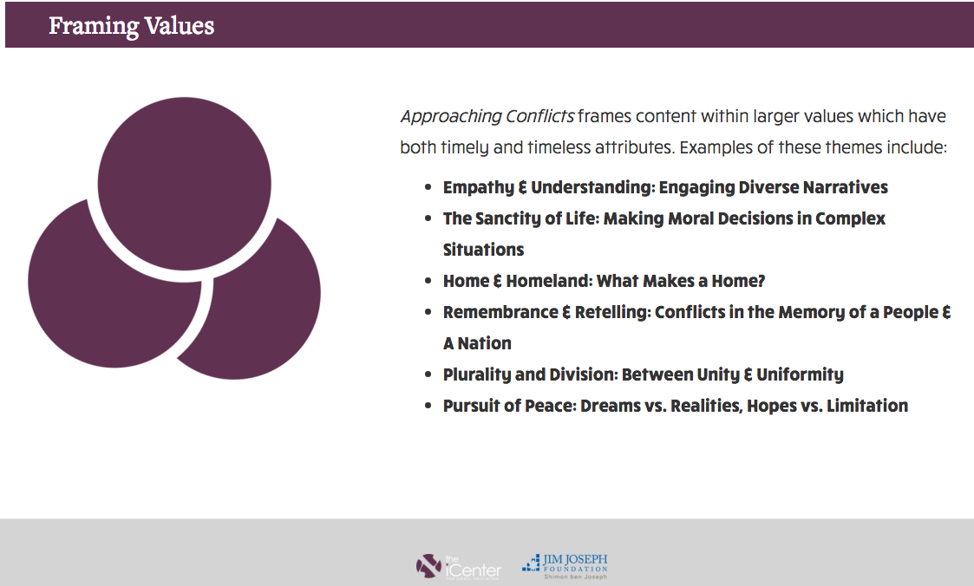

Letter to Congress Signed by 340 Rabbis:

August 17, 2015

Members of the U.S. House of Representatives
Members of the U.S. Senate

As rabbis, we support the agreement between the United States, the United Kingdom, France, Germany, China, Russia and Iran– The Joint Comprehensive Plan of Action. We encourage the members of the Senate and the House of Representatives to endorse this agreement.
The Obama administration has successfully brought together the major international powers to confront Iran over its nuclear ambitions. The broad international sanctions moved Iran to enter this historic agreement. Should this agreement be rejected by the U.S. Congress, those sanctions will end. There will be no new negotiations, as the other member countries are fully in favor of this agreement and have no desire to re-negotiate.
We understand that while this agreement blocks Iran’s path to a nuclear bomb, we recognize it does not deal with Iran’s support for terror, but that was never the purpose of these talks. Now that a nuclear agreement has been reached, we call on the United States and its international partners to strengthen their resolve and dedicate additional resources to confront Iranian threats to Israel and other states.
Most especially, we are deeply concerned with the impression that the leadership of the American Jewish community is united in opposition to the agreement. We, along with many other Jewish leaders, fully support this historic nuclear accord.

Letter and full list of rabbis: http://www.ameinu.net/newsroom/press-release/340-rabbis-urge-congress-to-support-nuclear-deal-with-iran/

