BBK LAYOUT
Indoor Gym or Outside Basketball Court: 2 Cones, 2 Basketballs, 1 Kickball

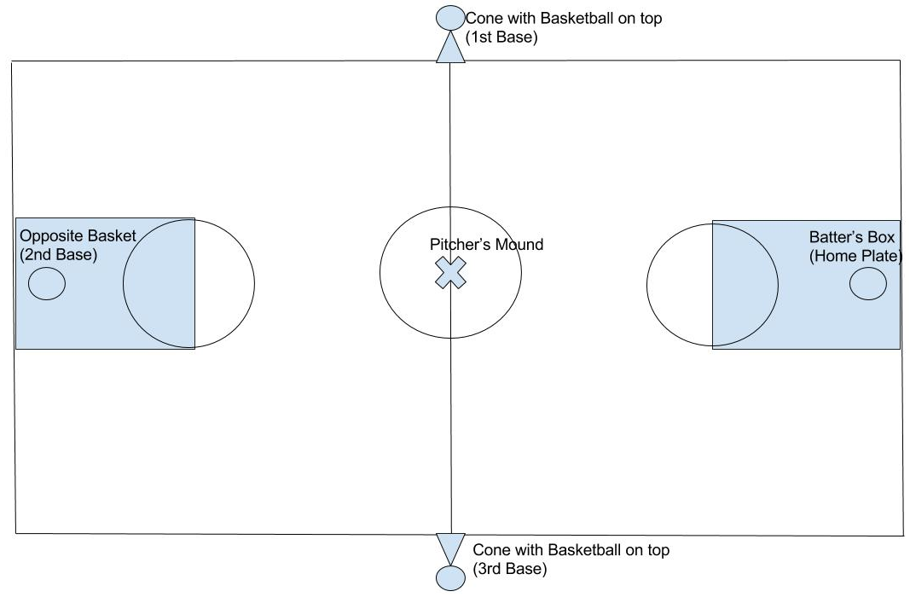
By Yoni Shear

