Playing Outside the Lines: Uncovering What’s Jewish about Camp Sports
Elective

Author(s): | Mara Berde
summary: | What’s Jewish about sports at camp? Can you act like a mensch while still being competitive? How can you use sports to build community? This session will combine active participation in a few popular camp sports and also will uncover the Jewish elements of sports at camp.  - Submitted by Mara Berde
Topic(s): | Sports, character development, community building
Learning Objective: | Participants will:  - Get outside and play sports together and build community  - Be able to use sports to build community and solve cabin issues  - Think critically about what it means to be a mensch (with a focus on humility, integrity, respect, and compassion)  - Look at texts (Jewish and secular) related to competition and sportsmanship
Audience: | Activities presented can be for 8-24 people, ages 10 and up
TIMING: | 90 minutes
AppendiCes: | - Spirit of the Game  - Quotes about Sports & Sportsmanship
Materials Needed: | - Gaga pit (or court set up using 6 rectangular tables)  - 2 Gaga balls (~10” diameter rubber playground balls)  - 3 Frisbees (175g)  - 3 small playground balls (6” diameter)  - 24+ disc cones or small soccer cones, preferably of various colors  - Copies of Spirit of the Game handout  - Copies of Quotes from Famous Athletes handout  - Copies of Jewish Texts on Sports & Sportsmanship handout  - Coach’s whistle  - Large post-it paper (10 sheets) & easel  - 6 thick markers for writing on poster paper
Set-UP DETAILS: | Outdoor sports court or grass area, preferably adjacent to gaga pit. (If no gaga pit available, can set up on flat surface using 6-8 rectangular tables.)

Session Timeline & Outline:

0:00 – 0:05 (5 minutes)
Welcome / Intro

Ask series of questions to get to know the group (sports background, competition), find out why they are here; give intro about what we will accomplish.

0:05 – 0:25 (20 minutes)
Part 1: Gaga

Describe the gaga pit at your camp? How do the kids act? It is orderly or completely uncontrollable? What is a counselor’s role at gaga pit? Is there any hope of making it an “educational” opportunity for the campers?

Let’s play! Explain rules, even if everyone knows how to play. Play first round with no additional instructions. If possible, have 2 people be the “observers” and watch for behaviors (Liaisons, if available, or Fellows who don’t want to participate). Observe behaviors of participants: is anyone super competitive? Who is on offense vs. defense? Is there any sort of teamwork? Are people exemplifying their camp’s values?

(Ideally some Fellows will have gotten really heated during the first round, calling each other out, cheating, etc. If not, play a second round where Fellows are told to act like their campers before they start.) After this round, pause for debrief.

Play another round, this time everyone must play with their non-dominant hand. Observe if/how the dynamic changed. Pause for discussion.

Depending on time, play another round, this time silently, while also acting like your campers. Observe their behaviors. Pause for discussion about focusing on your own actions versus pointing fingers or yelling about the faults of others. (While this may be fairly simple for adults, it can be really difficult for kids.)

Take questions; pause to discuss if/how they can imagine using this at camp? Does it make sense to make the entire unit stop and play silently? Probably not, at least not without a discussion. But you can start small with your cabin and get them to think about how their actions impact others.

0:25 – 0:40 (15 minutes)
Part 2: Spirit of the Game

At many camps, the cabins create a brit (covenant) that serves as cabin rules for the session. What if we were guided by ethics as opposed to “rules” and could use them as a guide for conversations with campers, rather than imposing rules?

In small groups, read through the Spirit of the Game handout. Discuss how each of the 5 statements are applicable to your life (as a person) and also how they’re relevant to sports, programs, and/or cabin life at camp.

Come back together with the large group and share what the small groups discussed. What do people think about the idea of a code of ethics rather than a list of rules?

0:40 - 1:10 (30 minutes)
Part 3: Using sports to build cabin community and solve issues

Sometimes, the best thing to do with your cabin is just get outside and play. Get them doing something together, something fun, something active. However, it’s inevitable that you will have kids with different levels of interest in organized sports, and a simple game of soccer or ultimate frisbee can turn into a cabin civil war (e.g., “We don’t want him on our team” or “She’s a ball hog” or “You suck”!). How can we make regular camp sports into games that the entire cabin will enjoy?

Before you begin: With your co-counselor, determine your goals for cabin time. What do you hope your cabin will accomplish/learn through sports? Is it just for fun and to get some exercise (that is a totally legit goal)? Are there certain issues that have come up that need to be addressed like cliques or campers not getting along? Campers respond well to transparency so being honest with them about your goals can make a big impact. Try using one of the cabin’s values or something from the Code of Ethics. Before you start playing, have a brief discussion with them about the kavannah (intention/ direction) for this cabin activity. *

* Setting an intention at the start of an activity is a great way to deepen the experience. More than an “intention”, kavannah also provides us with a “direction.” (Kavannah comes from the Hebrew כיוון “kivun” meaning direction.)

Step 1: Come up with a creative way of picking teams (e.g., get in line silently by birthday month, height, alphabetically, etc.) then split the team in half. Do not let the kids pick teams, it will become a popularity contest.

Step 2: Be clear about the rules. Even if you think “everyone knows this game,” it’s important to go over the rules in order to get to a shared understanding and level the playing field, so to speak.

Step 3: Play! Whether it’s ultimate frisbee, basketball, team handball, or anything else, let them play.

Step 4: Rather than a regular game, add creative rules that will allow different campers an opportunity to shine. Examples: make the teams smaller and play two mini games. Add a 2nd ball. Award extra points for teams that score after passing the ball to everyone on the team.

In small groups, brainstorm 3 new rules you can add and their intended outcomes. Share back with the larger group and make a big list.

Step 5: At the end of the cabin time, it’s important to stop and reflect. Experiences at camp are the most powerful when we take the time to reflect and acknowledge behavior that’s in line with our values or ethics. Ask your campers about their experiences. Have them give “shout-outs” to others who demonstrated kavannah or acted according to the cabin or camp’s code of ethics.

1:10 - 1:20 (10 minutes)
Being a Mensch: Our Actions On and Off the Field

Camps always talk about the fact that we’re trying to help each child become a mensch. But how do we do that and what are the actual traits that create a mensch? In camp and in life in general there are countless virtues that could be combined into being a mensch, but for the purpose of sports, we will focus on four: Integrity, Humility, Respect, Compassion.

Break the large group into 4 small groups. Give each group a paper with 1 of the 4 words on it. In your group, the first step is to create a definition. The second step is to list the practical application of this trait (e.g., What does integrity look like at camp specifically?). Discuss how this can be used with your campers and prepare to share back to the larger group.

1:20 - 1:30 (10 minutes)
Bringing it Back to Camp

Spend a few minutes journaling about this session. What did you learn? What are your takeaways? Do you have additional questions or are you unsure about something? Have people share with the larger group and leave a few minutes for questions.
Distribute sports quotes for reference/future use.

Additional Notes for Bringing it Back to Camp:

The above session is meant to educate Fellows as well as provide 2 replicable activities for their campers. The sports quotes & Jewish text handouts are just for reference and can be used in the cabin or sports activity at camp.

Five Things to Know about SPIRIT OF THE GAME

Ultimate Frisbee is governed by a code of ethics called “Spirit of the Game”. You will notice that even the Spirit of the Game principles, which were not created specifically for use by Jews, include many Jewish values and concepts. This is a version of the Spirit of the Game guidelines adapted specifically for use in Jewish summer camps.

1. The golden rule: treat others as you would want to be treated.
What is hateful to you, do not do to your fellow
Da-alach s’ni L’chavrach lo ta-aveid zu – Babylonian Talmud, Shabbat 31a
Spirited games result from mutual respect among opponents. Assume the best of your opponent. Give him or her the benefit of a doubt. You would want the same for yourself.
2. When you do the right thing, people notice.
Veer away from evil and do good.
Sur mei’ra v’ase tov – Psalms 34:15
Instead of yelling at your opponents to settle a disagreement on the field, talk to them calmly. This is all about role modeling, something that we talk about a lot at Jewish summer camps. When you do the right thing, you might not hear praise, but people do notice, and their respect for you and the game will grow.

3. Breathe.
My God, the soul you have given me is pure.
Elohai n’shama shenatata bi t’hora hi – Daily prayer book
In competitive sports, emotions run high. After a close call, or disputed play, take a step back, pause, and take a deep breath. By giving yourself just a bit of time and space, you will gain enough perspective to compose yourself and concentrate on the facts involved in the dispute (was she in or out; did you hit his hand or the disc; did that pick affect the play). Your restraint will induce a more restrained response from your opponent, and you will be able to settle it calmly.

4. Be generous with praise.
Judge each person generously.
Dan kol adam l’chaf z’chut – Pirkei Avot 1:6
Compliment an opponent on her good catch. Remark to a teammate that you admire his honesty in calling himself out of bounds. Look players in the eye and congratulate them when you shake their hands after a game. These small acts boost spirit greatly, a large payoff for little time and effort.
5. Have fun.
It is a big mitzvah to be always happy.
Mitzvah g’dolah l’hiyot b’simcha tamid. -Rabbi Nachman of Bratzlov
All other things being equal, games are far more fun without the antipathy. Go hard. Play fair. Have fun.

Professional Athletes on SPORTSMANSHIP

The following quotes can be printed and hung around a room, cut apart and laminated for use before/after sports activities, or just used to inspire conversation in the cabin.

The most important lesson I've learned from sports is how to be not only a gracious winner, but a good loser as well. Not everyone wins all the time, as a matter of fact, no one wins all the time. Winning is the easy part, losing is really tough. But, you learn more from one loss than you do from a million wins. You learn a lot about sportsmanship. I mean, it's really tough to shake the hand of someone who just beat you, and it's even harder to do it with a smile. If you can learn to do this and push through that pain, you will remember what that moment is like the next time you win and have a better sense of how those competitors around you feel. This experience will teach you a lot on and off the field!
- Amy Van Dyken, Olympic swimmer and 6-time gold medalist

"Sportsmanship for me is when a guy walks off the court and you really can't tell whether he won or lost, when he carries himself with pride either way."
- Jim Courier, World-champion Tennis player

I’ve missed more than 9,000 shots in my career, lost almost 300 games, missed the game-winning shot 26 times. I’ve failed over and over again in my life. That is why I succeed.
- Michael Jordan, professional basketball player

One man practicing good sportsmanship is far better than 50 others preaching it.
- Knute K. Rockne, college football coach (Notre Dame, 1918-1930)

Sportsmanship to me is going out and playing as hard as you can within the rules.
- Bobby Bowden, college football coach (Florida State, 1976-2009)

Sportsmanship is "making sure you have respect for the guy you're playing across from.”
- Warren Moon, professional football player

The most important decision I ever made in my career was to live my life in sports as honestly and ethically as possible. Never having compromised my values allows me to look back on my life with no regrets and feel satisfaction in what I was able to accomplish.
- Greg LeMond, professional cyclist and 3-time winner of the Tour de France

Athletic competition clearly defines the unique power of our attitude.
- Bart Starr, NFL player (Packers, 1956-1971) and coach (Green Bay Packers, 1975-1983)

Jewish Texts on SPORTS & SPORTSMANSHIP

Print the following quotes, cut apart and either laminate or tape to cardstock. On one side should be the quote and on the other side should be the discussion questions.

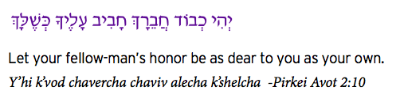

What does this quote mean in terms of sports and sportsmanship?
If you were honoring your teammates, what would that look like on the field?
If you were honoring your opponents, what would that look like?

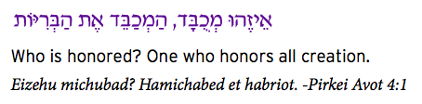

What does it mean to honor someone?
Do you agree that by honoring your opponents you also will gain honor?
What would that look like during a sports game?

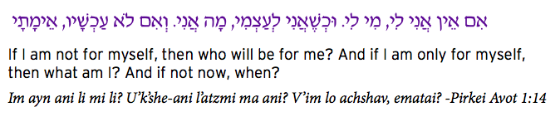

What does it mean to be “not for yourself” in a sports competition?
What does it mean to be “only for yourself?”
Can you think of an example of what this would mean in sports?

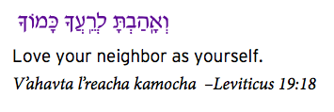

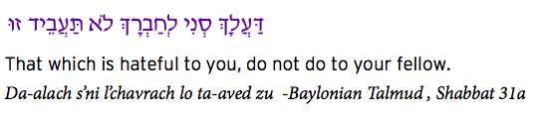

These two quotes talk about how to treat others. What do they mean in terms of sports?
How would you like to be treated on the field?
How should you treat others?

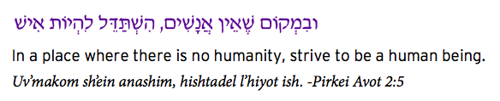

What kind of setting has “no humanity?”
What does the quote ask you to do by being human?
What might this mean in the context of sports and competition?

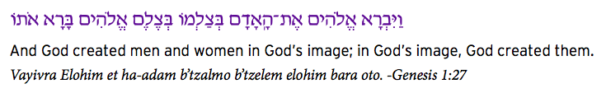

If we are all created in God’s image, why do some people get chosen first when picking teams?
How can we demonstrate our understanding of this value at the end of the game?

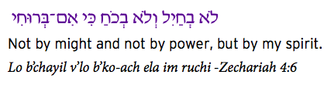

How do we balance effort with results?
How do we balance natural talent with hard work?
How do we balance skill on the ball field with enthusiasm for the sport?
Is there more to sports than athletic ability?

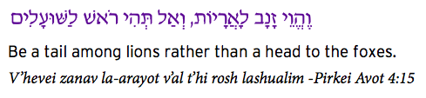

Who do you hang out with and why?
What kind of team do you want to be part of?
Do you need to be the star of the show, or can you contribute your best to the team you’re on?
What’s the best way to improve yourself?

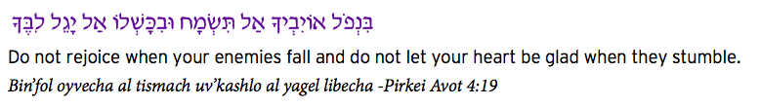

What is the proper way to celebrate winning?
How important is it to think about your opponent when you’ve just beaten them?
What do you think about “victory dances” like in the NFL?

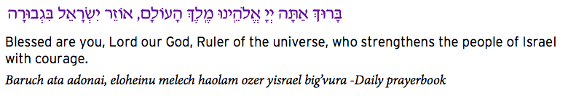
Do you get nervous before a game?
What do you do to help yourself focus?
How do you recognize the gifts you have that let you play sports?

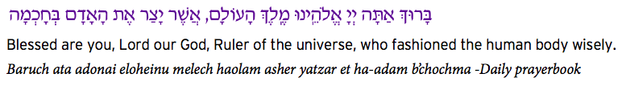

Have you ever been frustrated by an injury that kept you from playing sports?
What do you do to maintain your best health?
What is your responsibility for keeping fit enough to play well?

