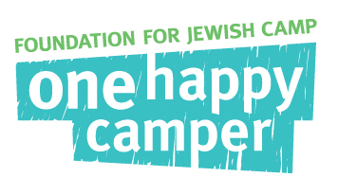
One Happy Camper – Community Partners
Peer Sharing Program Form

Partner Name: Cleveland

Name of Program or Event: Sunday Morning Bagel Shop

Date of Program or Event: Sundays during religious school

Target Audience: Families with religious school aged children

Number of Attendees: varied

Goal/Objective of Program or Event: to promote Jewish overnight camp and One Happy Camper, to keep camp present at the synagogue, to raise money for youth programming and camp scholarships

Event Location (type of venue): The Temple Tifereth Israel

Summary of Program or Event: The Bagel Shop highlighted different camps each Sunday morning during religious school. For $75 camps can sponsor this Sunday morning tradition. They either have camp staff or family ambassadors volunteer at the bagel shop talking about camp and meeting with parents before, during or after religious school. The funds cover the cost of the bagels so that all proceeds from the sale of the bagels can be used for scholarships for youth programs such as youth group events or camp.

Did this program/event proceed as planned? Why or why not? Yes

How would you improve this program, what would you do differently next time? We would like a wider participation by a greater variety of camps next year.

How did the program help children and/or families experience and/or connect with camp? The liaison was present each Sunday along with camp representatives to talk about camp and make connections with families and potential campers.

