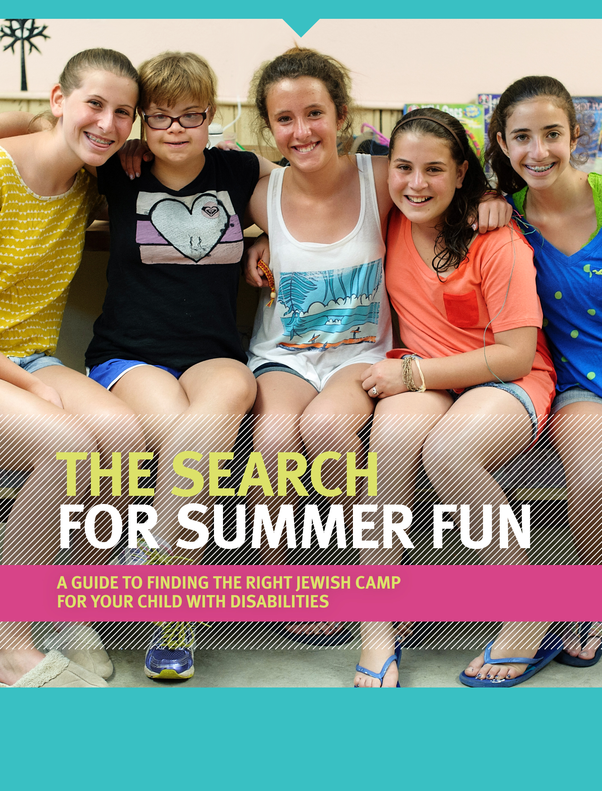
20000
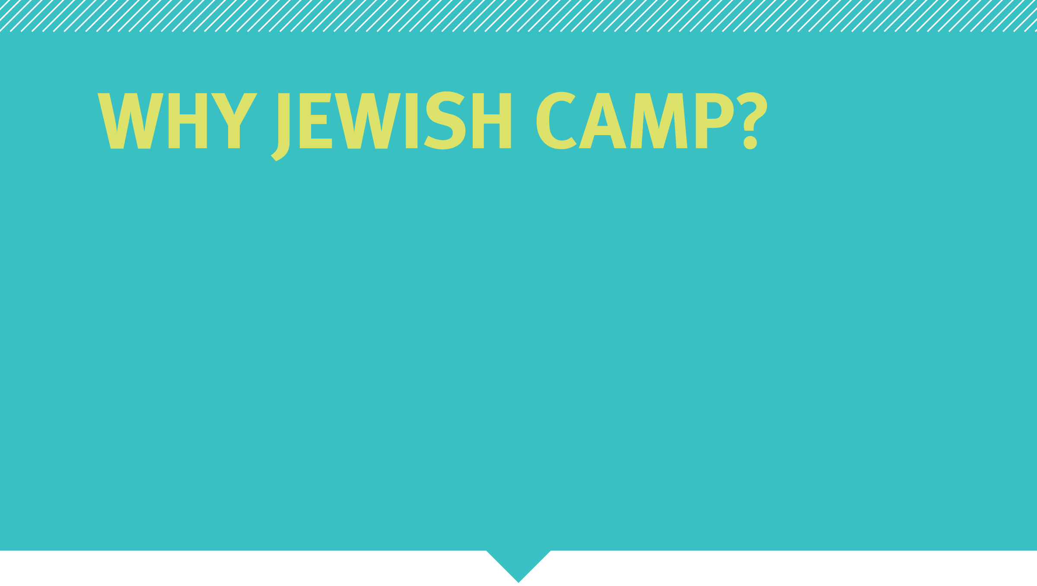
Summer overnight camp is about so much more than campfires and color war. It’s a chance for kids to explore who they are and who they want to become. At Jewish camp, ruach (spirit) is part of every activity—from dancing to hitting a home run—allowing campers to explore their connection to the Jewish community while having the summer of their lives. Campers are bunkmates and team players, artists and athletes, creative problem-solvers and blossoming leaders, developing independence and communication skills they can use their entire lives. The Foundation for Jewish Camp offers several opportunities to make sure that every child has access to an unforgettable Jewish summer experience. We know that there is a camp out there that matches your child’s interests and meets your needs—and we are here to help you find it!

Jewish camp is more than just camp.
For your child, Jewish camp is just plain fun. But it’s much more than that—it’s camp with a soul.
- Camp is exciting! Your kids will have the summer of their lives while also discovering values like independence, friendship, community, fairness, diversity, giving back, inclusion, integrity, collaboration, and heritage.
- Jewish camp is packed with action: boating, basketball, filmmaking, rock climbing, cooking, archery, painting, drama, dance—you name it!
- Camp promotes your child’s individual growth in an enriching Jewish environment. At camp, kids have cool, Jewish role models. Staff members inspire confidence and independence, guiding your child to think creatively, build self-esteem, listen and communicate more effectively, and discover interests and talents.
- The impact of overnight Jewish camp is immediate and lasting. Studies show that children who go to Jewish camp are more likely to become adults who value their heritage, are engaged in their communities, and support more causes throughout their lives.
- Campers become leaders. Camp activities emphasize independence, communication, problem solving, collaboration, and leadership – skills that have become necessary in our 21st century world.
- There’s a Jewish camp for everyone—no matter what your background is, there’s a Jewish camp where your child will have fun, be comfortable, learn more about themselves, and explore their Jewish identity.

With over 155 camps to choose from, our Find a Camp tool makes it easy to discover camps you and your kids will love, based on information such as where you live, your child’s grade, and the type of activities your child is looking for. Visit OneHappyCamper.org/FindaCamp to get started!

Need help narrowing down your options? Read on for a guided camp search and a list of camps that cater to your area.

Take a few minutes and think about the type of environment in which your child thrives. What kind of program will benefit them the most? What kind of experience are you and your child expecting from the summer? The right camp for your child becomes an extension of your home and your family’s values.

start with your child’s needs.
Finding the right camp is often about finding a community your child can be part of for summers to come. There are no right or wrong answers. Here are some questions to help in your family’s camp search.

- Do I want a traditional camp that gives my child a wide variety of experiences, or do I want to select a specialty camp that focuses on a particular activity or set of skills?
- Does my child need lots of instruction and structure? Or would they prefer to have more choices?
- Does my child have any special dietary or physical needs that the camp will need to accommodate?
- What size camp will make my child feel comfortable?
- Do I want the camp to be affiliated with a particular movement or organization?
- What session length will appeal to my child and to our family plans for the summer?
- What type of location are we looking for? Consider options like mountains and lakefront, but also distance from home.
- What is my budget for camp tuition?
- Do I want a camp program where staff is trained to meet the needs of my child with disabilities?
- Do a want a camp where my child will live with and attend activities with peers without disabilities; or a camp where my child will spend a portion but not their entire day with peers without disabilities; or a camp where all campers have a disability?
- Do I want a camp that offers a vocational training program?
- What level of independence will my child be given at camp?

Once you have thought a bit about what you are looking for, talk to your One Happy Camper representative or visit OneHappyCamper.org/FindaCamp to start selecting the camps you are interested in.

About tuition.
First-time campers may be eligible for a One Happy Camper grant of up to $1000. Visit OneHappyCamper.org to learn more.

Many camps offer early registration incentives or sibling discounts. Scholarships may be available from your camp, synagogue, or other Jewish organizations. Visit JewishCamp.org/camper-scholarships and contact your local synagogue or federation for additional information.

explore several camps.
The best way to get started is to visit each camp’s website, where you can find photos, maps or virtual tours of the camp facilities, and sample daily schedules. Websites will also inform you of key information about the directors and senior staff members, important dates, and registration information. From there, you can contact the camp speak to the director, schedule a visit with a camp staffer when they are in your area, set up a time to meet the parent of a current camper, or visit the camp if that is an option.
Every camp is different. From philosophy to facilities to food, there are as many unique approaches as there are camps. Asking questions, talking to staff, and getting familiar with what several different camps have to offer is the best way to narrow down which one is right for your child.

Every camp is different. From philosophy to facilities to food, there are as many unique approaches as there are camps. Asking questions, talking to staff, and getting familiar with what several different camps have to offer is the best way to narrow down which one is right for your child.

Below, you’ll find information on regional camps and a list of questions to guide you as you gather information. However, each family’s search is different, so focus on what is relevant and important to you. You can discover more Jewish camp options at OneHappyCamper.org/FindaCamp.

Camps to check out
Camp Name  City, State  website | Camp Name  City, State  website | Camp Name  City, State  website
Camp Name  City, State  website | Camp Name  City, State  website | Camp Name  City, State  website
Camp Name  City, State  website | Camp Name  City, State  website | Camp Name  City, State  website

(Camps continued)
Camp Name  City, State  website | Camp Name  City, State  website | Camp Name  City, State  website
Camp Name  City, State  website | Camp Name  City, State  website | Camp Name  City, State  website
Camp Name  City, State  website | Camp Name  City, State  website | Camp Name  City, State  website

questions to consider

About the Camp
- What are the camp's values and philosophies? What makes the camp special?
- Is the camp co-ed? What is the interaction like between different ages and different genders?
- What is the size of the camp? How are the campers grouped? How many kids are in each bunk?
- What percent of campers return each year?
- What is the total cost of the camp? Are there specialty programs or trips that cost extra? Will you need to provide spending money?
- How does the camp ensure campers’ safety and security? How is security handled out of camp?
- How are behavioral and disciplinary problems handled?
- What is the camp’s technology policy?
- Does the camp offer transportation to and/or from camp?
- What is the minimum age of the counselors? What kind of staff training is provided?
- What training is offered for staff working with campers with disabilities?
- What is the camper to staff ratio?

Judaism
- Is the camp affiliated with any movement?
- How are Jewish experiences incorporated into the camp program? (i.e., Shabbat, services, rituals, Hebrew, etc.)
- Are there special accommodations made so that my child will be able to have a meaningful experience of Shabbat services or Judaic programming?

Facilities and Programming
- What facilities are there, such as a lake or pool?
- What are the sleeping arrangements? Are showers/bathrooms in the cabins or in another building?
- What is the schedule like? Is the program structured or does it emphasize elective and individual choices? In what areas does the camp focus on skill-building?
- What type of instructional swim program is offered? Is it required? Until what age?
- What other instructional or specialty programs are offered?
- What types of programs and facilities are available in the event of bad weather?
- How does the camp program meet individual needs and differences?
- Do you offer assistance with showering, dressing, and toileting?
- How do you accommodate children who need a bit more sleep than allowed in the schedule?

Food and Medical
- What types of food are offered at camp? Can food allergies or other dietary needs be accommodated? Are snacks offered throughout the day? What if my child has a very limited diet?
- Is the kitchen kosher?
- How does the camp handle individual medical needs? What medical facilities are nearby?

Communication with Parents
- What contact will I be able to have with my camper while they are at camp?
- Will I be able to speak to a staff member while my child is at camp?
- What information (newsletters, emails, photos, calls) do you have with parents during the summer?
- Can the camp describe in detail what it does for a child with disabilities?
- Will the camp share information about friendships that are made at camp so that they can be maintained throughout the year?

about one happy camper
One Happy Camper provides grants of up to $1000 to families with children attending nonprofit Jewish overnight camp for the first time.
One Happy Camper is a program of the Foundation for Jewish Camp (FJC), in partnership with local
Jewish federations and other organizations, providing support to families like yours.

How do I apply for a One Happy Camper grant?
- Register your child. Once you've found the right camp for your child, register directly with the camp.
- Apply online for a One Happy Camper grant. Once your child’s registration at camp has been confirmed, visit OneHappyCamper.org and complete our simple online application form.
- Check back in two to four weeks. Your local One Happy Camper administrator will contact you once your application has been approved, or you can check your status online by logging in and selecting "Track My Grant.” Once your application has been approved, funds will be paid directly to the camp and will be credited towards your balance. Funds are paid to the camp each spring.

Is my child eligible?
To be eligible for a One Happy Camper grant, typically your child must be:
- Registered for an overnight camp listed on the Foundation for Jewish Camp’s website.
- Attending an approved overnight camp for the first time for at least 12 consecutive days.
- Not currently participating in a daily immersive Jewish experience, such as a Jewish day school or immersion program. (However, check with your local One Happy Camper administrator for additional opportunities.)
- Additional requirements and opportunities may be in place in some areas.

If you have questions about eligibility or regarding your application, please follow up with your local
One Happy Camper administrator [PARTNERS CUSTOMIZE WITH CONTACT INFO]. To find administrator listings by state, visit OneHappyCamper.org.

