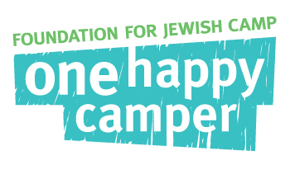
One Happy Camper – Community Partners
Peer Sharing Program Form

Partner Name: Hartford, CT

Name of Program or Event: Packing for Camp

Date of Program or Event: We usually do it in early May

Target Audience: One Happy Camper Parents and kids

Number of Attendees: About 15-20 families

Goal/Objective of Program or Event:
- To help first time camp parents get ready for camp by learning from “veteran” camp parents and f rom talking to each other.
- To give OCH families a chance to meet each other and make connections
- To create enthusiasm among OHC families about a camp and the OHC program

Event Location (type of venue):
Originally we had planned on doing it at an outdoor, camp-ish location, but the first two years we had rain and had to make last-minute changes. Now we do it in a local synagogue and sit around an indoor campfire..

Summary of Program or Event:

1. We invite 3-4 OHC parents from the previous summer to lead a panel discussion about “packing for camp. In advance we give them suggested topics and questions to think ab out (see attached)

2. While parents are talking, sharing, asking, etc, kids are in another space with our Israeli Young Emissaries doing fun camp-ish type games.

3. After about an hour, we bring everyone together and share what they’re most excited about. Then we give all the kids gifts.(t-shirts, hats, other fun swag)

4. We do an ice cream bar afterwards and everyone stays and schmoozes for quite a while!

Did this program/event proceed as planned? Why or why not?

How would you improve this program, what would you do differently next time?

How did the program help children and/or families experience and/or connect with camp?

