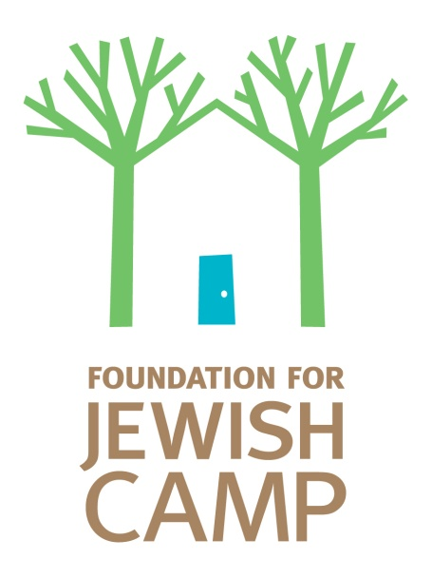 | memorandum
 | To: OHC Community partners
 | From: seth cohen & rebecca kahn
 | cc:
 | Date: AUGUST 17, 2013
 | Regarding: Tools to help generate support

Over the past few years we have been developing tools for your agency to use to grow and sustain One Happy Camper and other Jewish camp initiatives. Here is an overview of some of these tools – including a brand new one – a customizable PowerPoint presentation.

- Communities investing in the Future, One Happy Camper at a Time (WWW.JEWISHCAMP.ORG/COMMUNITY) This booklet is intended for donors and it outlines why camp, why OHC and how other communities across North America are supporting Jewish overnight camp.

- Camp Works Video (www.jewishcamp.org/campworksvideo) – A great visual piece that outlines the Camp Works study and shows the work FJC is doing to elevate Jewish overnight camp.

- Camp Works Statistical Highlights & Full Study –a brochure summarizing the findings of the impact of Jewish overnight camp and full detail report. (www.jewishcamp.org/research)

- OHC Annual Evaluation Report – North American Executive Summary and your community report – these serve to show the impact the incentive is having on your families.

On the marketing site is a postcard and a PowerPoint designed to help you further cultivate support for your Jewish camping agenda. These new items can be used for various audiences:
- Donors/Foundations
- Lay leaders
- Federation colleagues

It will be a rare occasion when you will need to use all the slides provided. Be sure to customize and edit depending on the audience and the length of time you have for the presentation. We have also included talking points (in the notes section) for many of the slides. These are suggested, so feel free to change them as appropriate. In addition, in bold/underline, we’ve indicated where you should include local data.

You’ll also note, that on each slide it suggests you swap out the generic OHC logo for your local OHC logo. Please be sure to make the change on every slide (or at the minimum delete the note saying to swap it).

Lastly, there is one slide that is a video. You have two options for using this slide:
- Use as is – currently linked to youtube site
- Work with your IT dept to imbed the video (contact FJC to receive the video file)

Please contact Rebecca at rebeccak@jewishcamp.org or 646-278-4545 with any questions. As always we are here to support you as you continue to advance your local camping agenda.

Thank you for your on-going partnership.

The One Happy Camper team

