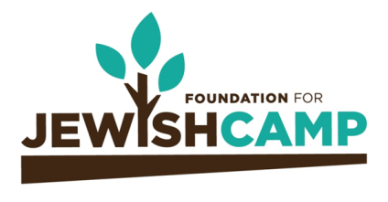
A Vibrant Jewish Future.
Our Holy Mission. Your lASTING Legacy.
A planned gift to Foundation for Jewish Camp (FJC) ensures your legacy and the Jewish future for generations to come. Jewish camp is the best vehicle to secure a vibrant Jewish community and FJC has been the catalyst for growth in the field of Jewish camp for over 20 years. Your legacy gift will support FJC’s holy mission after your lifetime by ensuring transformational immersive Jewish experiences.
*Optional - I/We are proud to declare my/our intent to leave a legacy gift to Foundation for Jewish Camp: (Please check all that apply.)
- A bequest in my/our will or trust
- A charitable remainder or lead trust
- A life insurance gift
- A retirement plan gift
- Other: ____________
The amount of my/our planned gift is: $________________ or ______% of my/our estate.
I/We intend to include FJC in my/our estate plans by the following date: _______________________
Name(s) as I/we would like it (them) to appear upon recognition:
_____________________________________________________________________________________
- I/We wish to include FJC in legacy planning but wish to remain anonymous.

Address: ____________________________________________________________________________
City: __________________________ State: _________________________ Zip: _______________
Cell Phone: ______________________________ Home Phone: _____________________________
Email address: _______________________________________________________________________
Signature: ______________________________________ Date: _____________________________

Return this form to:

Foundation for Jewish Camp
Attn: Planned Giving
253 West 35th Street 4th Floor
New York, New York 10001
For more information, contact:
Corey Cutler
Director of Development
Corey@jewishcamp.org
646 278 4584

The Jewish Future is stronger thanks to your everlasting generosity.

